Foundation
- Portal means specific application, specific technology which fulfill specific needs.
- CXP – Customer Experience Portal
- CXP Manager – Environment where we can do the development
- Enterprise catalog - Portal catalog – Page
- Portals – Pages – Containers – widgets
- http://localhost:7777/portalserver/retail-banking-demo/index?enable-mocks
- widget-hsbc-account-summary-ng.
- Bb-generate widget ng
- bb-package project or we can compile widget also by giving whole path
- bb-import package.zip
How portal render
- It search the reference of the portal inside DB
- Than it goes for Authentication & Authorization.
- Than it checks the template type
- Than it render on the browser

https://bitbucket.org/dashboard/overview
https://bitbucket.org/backbase/cxp-fe2-m00-training-overview
Id – training@backbase.com
Search Keyword – cxp-fe2-m00

Download Dependencies

CXP Developer Essentials Frontend

Module 0 : Setup your Development Environment

Prerequisites
Before going through this guide you must have the Backbase CXP software properly installed in your system. If you haven't met this prerequisite yet, read the following how to guide: Setting Up CXP 5.6.x and Widget Collection 2.x from Scratch

BB-CLI additional commands

bb-convert
bb-convert will help us to convert RAML files into data providers.
- Install and test that the bb-convert command is installed.
- npm install --global @bb-cli/bb-convert
- bb-convert --help

bb-watch
bb-watch is an easy to use watcher for backbase widget, extentions, ui components or themes.
- Install and test that the bb-watch command is installed.
- npm install --global @bb-cli/bb-watch
- bb-watch --help
Tip: You can run bb-watch project ./collection-training from statics folder to start the watcher.

bb-config
- Install and test that the bb-config command is installed.
- npm install --global @bb-cli/bb-config
- bb-config --help
- Navigate to your project statics folder and create a file named .bbconfig, then add to it the following contents:
- {
- "default": {
- "portal-host": "localhost",
- "portal-port": 7777,
- "build-plugins": "sass",
- "prebuilt" : "collection-training/prebuilt",
- "exclude-defaults" : "true"
- }
- }
Notes: We are going to use this .bbconfig -project specific- file for training purposes, it will provide a basic config profile for our dev environment. bb-config offers the possibility to work with global and project specific config files combined, and it also offers the ability to use named profiles for different environments. Read the following article for more details.

Install BB-CLI generators
In order to start generating items for our portal we will need to install the required generators:
- Run:
- npm install --global @backbase/generator-project-statics @backbase/generator-model-ng @backbase/generator-widget@2.4.3 @backbase/generator-ui-ng @backbase/generator-ext-ng@2.1.0 @backbase/generator-container

Install BB-CLI additional plugins
We are going to install additional plugins to offer Sass support:
- Run:
- npm install --global @bb-cli/bb-build-plugin-sass
Note: There are many other bb-cli commands, take a look at the following link if you want to check them out: document

Setup the Training Portal
In order to start working with the exercises you will need a fresh Portal.
- Create a new portal called "Frontend Training Portal"

Get the Retail Banking Masterpage
- Go to your portal catalog.
- In the Enterprise Catalog Section look for Retail Banking Master Page.
- Add the Retail Banking Master Page to your portal.
- Open Page Management, under Master Pages select Retail Banking Master Page.
- Add Manageable Area from Portal Catalog on Retail Banking Master Page

Edit the default page to use the Retail Banking Masterpage
- Edit the Default Page
- Choose Retail Banking Master Page option from the Master Page dropdown
- Save your changes
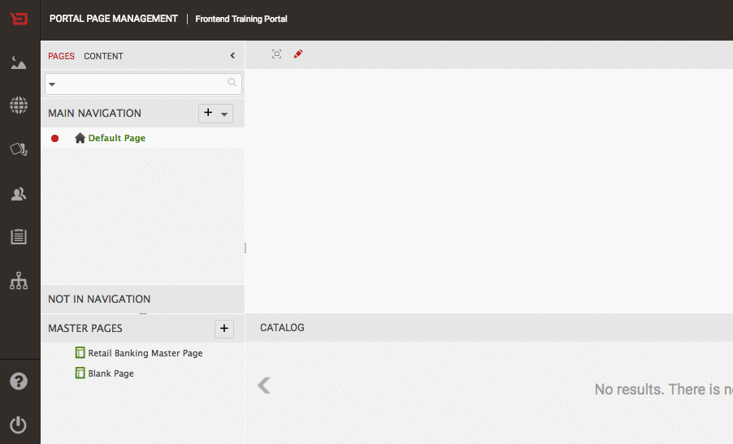

Widget Development

Module 01 - Exercise 01 : Extending the Contact Manager Widget
Generate a new extension for the Contact Manager Widget in order to achieve the following layout, displaying name, mail, and the list of products owned by the customer.
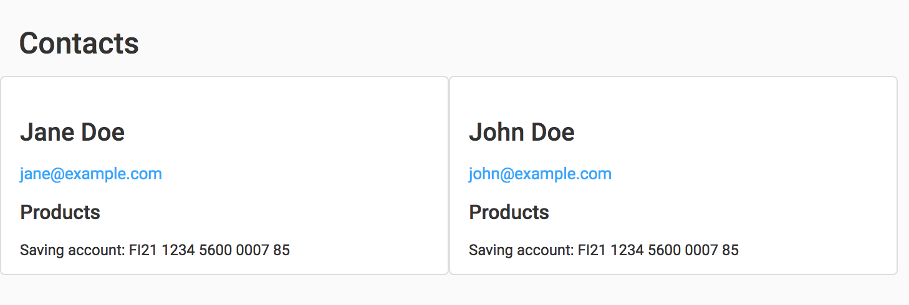
NOTES:
- Check the Contact API to know which properties are available:
http://docs.backbase.com/extranet/technical-docs/endpoints/v2/contact-presentation-spec.html

1 - Generate an extension for the Contact Manager
- Generate an extension using the generator:
  - Navigate to statics/collection-training/src folder;
  - Run:
  - bb-generate ext-ng
- Answers to generate the extension:
- Name == > ext-training-contact-tiles-ng
- Description - --- Accept default value ---
- WidgetController == > ContactController
- Version - --- Accept default value ---

2 - Add markup
- Open the file statics/collection-training/src/ext-training-contact-tiles-ng/templates/template.ng.html;
- Replace the content of that file by the following snippet:
- <section class="ext-training-contact-tiles-ng" ng-controller="ContactController as $ctrl">
- <div class="container-fluid">
- <h2>
- Contacts
- </h2>
- <div class="row">
- <ul>
- <li class="contact col-sm-12 col-md-4 col-lg-3 list-group-item justify-content-between" ng-class="{'list-group-item-minheight' : contact.accounts }" ng-repeat="contact in $ctrl.state.contacts.data track by contact.id">

- <h3>{{ contact.name }}</h3>
- <a href="mailto:{{ contact.emailId }}">{{ contact.emailId }}</a>

- <h4>Products</h4>
- <ul class="contact-products">
- <li ng-repeat="account in contact.accounts">
- <small>{{account.name}}: {{ account.IBAN }}</small>
- </li>
- </ul>

- </li>
- </ul>
- </div>
- </div>
- </section>

3 - Import to CXP Manager
- Navigate to statics;
- Use bb-cli to package the whole collection:
bb-package collection-training/src
Check if a package.zip file has been created.
- Use bb-cli to import the whole collection:
bb-import package.zip

4 - Switch extension to test it
- Open your portal;
- Create a new page called Contacts;
- Search for Contact Manager widget in your portal catalog (if not there please add it to your catalog);
- Drop a Contacts widget on your new page;
- Click in Contact Manager widget to see the widget top bar;
- Click in the settings icon to see the preferences dialog;
- Change the Extension property value to:
ext-training-contact-tiles-ng
- Click on the Preview page link to preview the page. Add ?enable-mocks to enable the mock data.
- Now you can see the widget showing contacts as tiles.

Module 01 - Exercise 02 : Generating an UI Component
Generate a Contact Tile UI component: The objective of this exercise is to create a UI Component for the Contact Tile that we were using in the previous exercise.
Refactor the extension template that you created in the previous exercise and use the UI component that you just created.

1 - Generate a new UI Component
- Navigate to statics/collection-training/src;
- Generate a UI Component by running: bb-generate ui-ng command
- Answers to generate the UI Component:
- Name == > ui-training-contact-details-ng
- Description - Training Contact Details
- Version - --- Accept default value ---

2 - Modify the UI Component template so it displays a Contact Tile:
- Open src/ui-training-contact-details-ng/scripts/component.js file
- Modify the template as follows:
- template: `
- <li class="contact col-sm-12 col-md-4 col-lg-3 list-group-item justify-content-between">
- <h3>{{ $ctrl.contact.name }}</h3>
- <a href="mailto:{{ $ctrl.contact.emailId }}">{{ $ctrl.contact.emailId }}</a>
- <h4>Products</h4>
- <ul class="contact-products">
- <li ng-repeat="account in $ctrl.contact.accounts">
- <small>{{account.name}}: {{ account.IBAN }}</small>
- </li>
- </ul>
- </li>
- `,

3 - Adjust the UI Component's bindings
- Open the file src/ui-training-contact-details-ng/scripts/component.js file
- Delete the config property binding
- Create a new binding for the contact property, binding type: one-way binding
- bindings: {
- contact: '<',
- onSelect: '&',
- }

4 - Modify the extension to implement the Contact Tile UI Component
- Open statics/collection-training/src/ext-training-contact-tiles-ng/templates/template.ng.html
- Replace the li.contact element by the following:
- <ui-training-contact-details-ng contact="contact" ng-repeat="contact in $ctrl.state.contacts.data track by contact.id" />
- Open statics/collection-training/src/ext-training-contact-tiles-ng/scripts/index.js
- Search for:
- export const dependencyKeys = [
- ngAriaModuleKey,
- ];
- Replace it by the following:
- import uiTrainingContactDetailsNg from 'ui-training-contact-details-ng';
- export const dependencyKeys = [
- ngAriaModuleKey,
- uiTrainingContactDetailsNg,
- ];

Adding Styles to your portal
In this exercise you are going to create a Theme for your portal, and add some styling to your contact tiles extension.
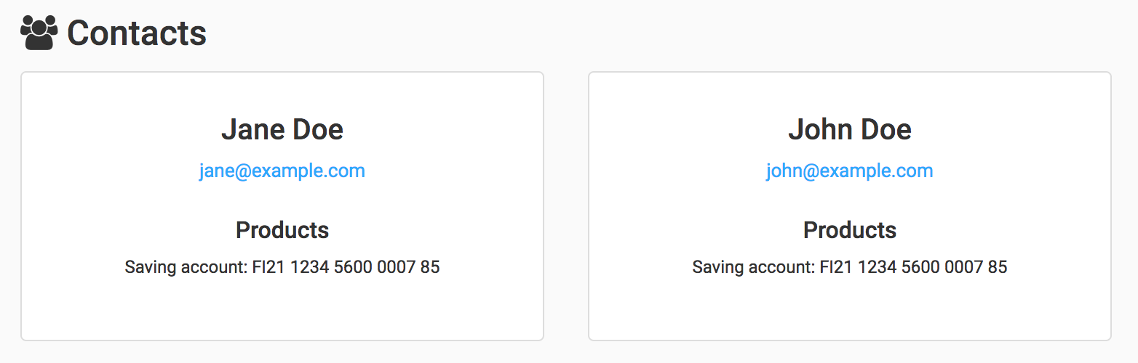

Generate a copy of the Backbase Retail Theme (theme-bb-retail) customizing-it it
- Navigate to statics folder
- Copy the default theme from the source folder to create your own theme.
- bb-customize item theme-bb-retail collection-training/src --new-name theme-training-default

Set the title and version in model.xml
- Navigate to statics/collection-training/src/theme-training-default
  - Edit the file model.xml
  - Modify the title property from Theme for Retail Banking Collection to Theme Training Default
  - Modify the version property value to 0.0.1

Import to CXP Manager
- Navigate to statics
- Use bb-cli to package your items:
- bb-package project
Check if a package.zip file has been created.
- Use bb-cli to import your items to the portal:
- bb-import package.zip
- Switch the theme in Retail Banking Master Page to use the new theme.

2 - Add styles to your extension in order to make it look as similar as possible to the example shown below

Adding custom variables to your theme
- Navigate to statics/collection-training/src/theme-training-default/styles
- Edit the file _theme-custom-variables.scss
- Add a new variable below $information-sm-screen as follows:
- $information-md-screen: "(min-width : 892px)";

Adding extension specific styling
- Navigate to statics/collection-training/src/theme-training-default/styles/components/
- Create the folder: ui-training-components and navigate to it.
- Create a new file called _contact-details.scss and add the following content to it:
- .training-contact-details {
- padding: 20px;

- h3 {
- margin: 5px 0;
- }

- h4 {
- margin: 20px 0 5px 0;
- }

- &.contact {
- text-align: center;
- margin: 0 15px;
- }

- .img-thumbnail {
- max-width: 200px;
- }

- .contact-avatar {
- width: 50%;
- }

- .list-group-item {
- border-radius: 10px;
- margin: 15px 0;
- box-shadow: 0px 1px 1px $gray89;

- @media #{$information-md-screen} {
- margin: 15px;
- }

- &:first-child {
- margin-left: 0;
- }
- }

- .contact-products {
- min-height: 40px;
- }
- }
- Create a new file _ui-training-components.scss in the components folder and add the following content to it:
- @import "ui-training-components/contact-details";
- Open the file statics/collection-training/src/theme-training-default/styles/_components.scss and add the following line:
- @import "components/ui-training-components";

Modifying the extension template
- Navigate to statics/collection-training/src/ext-training-contact-tiles-ng/templates
- Edit the file template.ng.html
- Replace the Contacts title (H2 tag) with the following markup
- <h2>
- <i class="fa fa-users"></i>
- Contacts
- </h2>

Modifying the extension template
- Navigate to statics/collection-training/src/ui-training-contact-details-ng/
- Edit the template property in the component.js
- Add the class "training-contact-details" to the outer li tag
- <li class="training-contact-details contact col-sm-12 col-md-4 col-lg-3 list-group-item justify-content-between">

Import to CXP Manager
- Navigate to statics
- Use bb-cli to package your items:
- bb-package project
Check if a package.zip file has been created.
- Use bb-cli to import your items to the portal:
- bb-import package.zip

Hooks
The objective of this exercise is to enrich your data layer by using Hooks. You are going to add avatar images for the contacts that are being listed. In order to display the avatar image, use the Random User Generator API, for instance: https://randomuser.me/api/portraits/lego/1.jpg.

1. Find a hook that allow you to handle the Contacts List data
Check the available hooks for the Contact Widget here: Contact Widget API Documentation.
The hook that meets our requirements is processContacts(contacts)

2. Implement the hook in the extension
This implementation must add a imageAvatar field to every contact in the list. The field's value should be the avatar image url.
- Navigate to statics/collection-training/src/ext-training-contact-tiles-ng/scripts;
- Create a new file and name it hooks.js;
- Add the following snippet of code into it:
- const RANDOM_USER_API_ENDPOINT = 'randomUserApiEndpoint';
- export default (context) => {
- const randomUserApiEndpoint = context.widget.getStringPreference(RANDOM_USER_API_ENDPOINT);
- return {
- processContacts: (contacts) => {
- return contacts.map((contact, index) => {
- contact.imageAvatar =
- (randomUserApiEndpoint) ? randomUserApiEndpoint.replace('${userIndex}', index + '.jpg') : "nullAvatar.jpg";
- return contact;
- });
- }
- };
- };
- Open statics/collection-training/src/ext-training-contact-tiles-ng/scripts/index.js
- Search for:
- import '../styles/index.css';
- Below that line add:
- import extHooks from './hooks';
- Search for:
- export const hooks = {};
- Replace it by the next code snippet:
- export const hooks = (context) => {
- return extHooks(context);
- };
- Import to CXP Manager using bb-package and bb-import

3. Use the avatar UI Component provided by Backbase to display the avatar image
Check the Retail Banking Collection API Documentation. The UI Component name that we are going to implement is ui-bb-avatar-ng
- Open the file statics/collection-training/src/ui-training-contact-details-ng/scripts/component.js
- Under template property, add the following UI component before h3:
- <ui-bb-avatar class="media img-circle img-thumbnail" name="$ctrl.contact.name" image="$ctrl.contact.imageAvatar"></ui-bb-avatar>
- Open the file statics/collection-training/src/ui-training-contact-details-ng/scripts/index.js
- Import the required dependency for bb avatar UI component:
- import uiBbAvatarKey from 'ui-bb-avatar-ng';
- Add the dependency:
- export default angular
- .module('ui-training-contact-details-ng', [uiBbAvatarKey])
- .component('uiTrainingContactDetailsNg', component)
- .name;

4. Add Extension-Specific Preference
In order to keep the extension source code as generic as possible we should make use of preferences. This will allow us to change preferences values without modifying the extension's code. Adding extension-specific preferences must be done in CXP Explorer.
- Open Explorer App
- Search for Contact Manager instance in the tree in the left sidebar and click on it
- Click on the Properties tab
- Click on the + sign
- A new modal will be shown to input the new property
- Set the Name input value to:
- randomUserApiEndpoint
- Set the Label input value to:
- Random User API endpoint
- Set the value input value to:
- https://randomuser.me/api/portraits/lego/${userIndex}
- Save it.

Helpers
The objective of this exercise is to, using the Contact Manager Widget's preference pageSize, make the property editable in the widget extension template.

1 - Modify the template to include the input elements
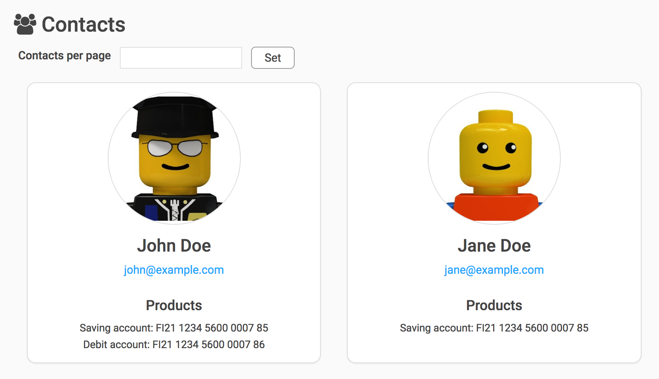
- Open the file statics/collection-training/src/ext-training-contact-tiles-ng/templates/template.ng.html;
- Replace the content of that file by the following snippet:
- <section class="ext-training-contact-tiles-ng" ng-controller="ContactController as $ctrl">
- <div class="container-fluid">
- <h2>
- <i class="fa fa-users"></i>
- Contacts
- </h2>
- <div class="row filters">
- <label>Contacts per page</label>
- <input type="text" ng-model="pageSize"/>
- <button ng-click="ext.helpers.setPageSize(pageSize)">Set</button>
- </div>
- <div class="row">
- <ul>
- <ui-training-contact-details-ng contact="contact" ng-repeat="contact in $ctrl.state.contacts.data track by contact.id" />
- </ul>
- </div>
- </div>
- </section>
- Create the file statics/collection-training/src/theme-training-default/styles/widgets/_contact-tiles.scss;
- Add the following styling rules in the created file:
- .filters {
- label,
- input,
- button {
- float: left;
- }

- label {
- margin-left: 20px;
- }

- input {
- margin: 0 10px;
- }

- button {
- background: $white;
- border: 1px solid $gray60;
- border-radius: 5px;
- padding: 2px 15px;
- }
- }
- Open the file statics/collection-training/src/theme-training-default/styles/widgets/_all.scss;
- Add the following line:
- @import "contact-tiles";

2 - Add a helper that saves the preference
And reload the page after saving the preference.
- Open the file statics/collection-training/src/ext-training-contact-tiles-ng/scripts/index.js;
- Replace the helpers code of that file by the following snippet:
- export const helpers = ({widget}) => ({
- setPageSize: (size) => {
- widget.savePreference('bb.contact.pageSize', size);
- location.reload();
- }
- });

Custome Widget Development

Module 01 - Exercise 07 : Develop Functionality
In this exercise you will create a new method in the Widget's controller to sort appointments by date.
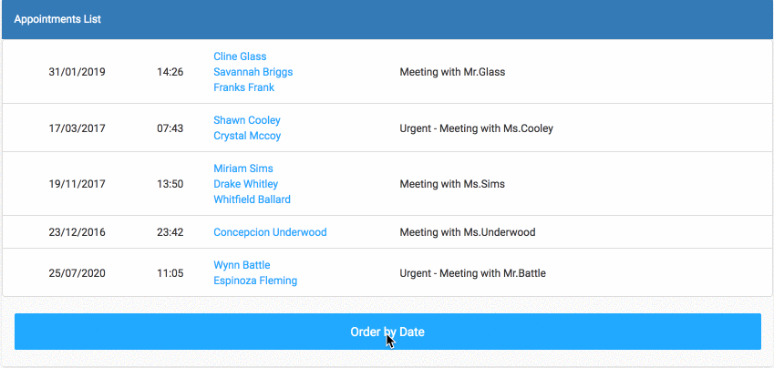

Instructions

Develop Sorting Functionality
- Open template.ng.html in ext-training-appointments-ng and add the orderBy filter of AngularJS to the Contact list item being iterated:
- <li class="list-group-item vertical-center" ng-repeat="item in $ctrl.appointments | orderBy:$ctrl.sortByProp">
- Add a button in the template, in the footer using the following code:
- <div class="panel-footer">
- <button type="button"
- class="btn btn-primary btn-block"
- ng-click="$ctrl.sortByDate()">
- {{ $ctrl.sortByProp === '' ? 'Order by Date' : 'Reset' }}
- </button>
- </div>
- Open controller.js in widget-training-appointments-ng Implement the logic in the Controller that will order the appointments by date:
  - Initialize the "sortByProp":
  - $ctrl.sortByProp = '';
  - Implement click event handler:
  - const sortByDate = () => {
  - $ctrl.sortByProp = $ctrl.sortByProp === '' ? 'date' : '';
  - };
  - Assign it to Controller:
  - Object.assign($ctrl, {
  - $onInit,
  - sortByDate,
  - ...

Module 01 - Exercise 08 : Inter-Widget Communication
As you just learned, Backbase Widgets make use of the Pub-Sub pattern for Inter-Widget communication.
In this exercise we will learn how to implement the Pub-Sub pattern to send data between two different widgets.
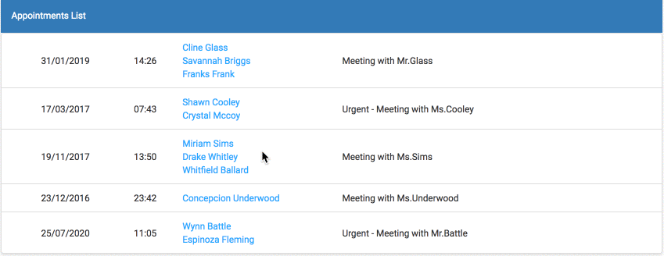

Instructions

Trigger an event when clicking an appointment's row

Create a new method in the Appointment widget controller.
- Open statics/collection-training/src/widget-training-appointments-ng/scripts/controller.js file
- Implement the publish:
- const onSelectAppointments = (appointment) => {
- bus.publish('training.event.appointment.selected', appointment);
- };
- Assign it to Controller:
- Object.assign($ctrl, {
- $onInit,
- ...
- onSelectAppointments,
- ...
- Open statics/collection-training/src/ext-training-appointments-ng/templates/template.ng.html

Modify the Appointments widget template to add the ng-click directive to every appointment row.
- Modify the appointment row markup as follows:
- <li class="list-group-item vertical-center" ng-click="$ctrl.onSelectAppointments(item)"

Develop the Appointments Details Widget
This widget will be in charge of listening the event being triggered by the Appointments widget, and displaying the appointment data in a modal.

Generate the Appointments Details widget
- Navigate to statics/collection-training/src folder
- Run:
- bb-generate widget ng
- Answers to generate the widget
- Name == > widget-training-appointments-details-ng
- Title - --- Accept default value ---
- Description - --- Accept default value ---
- Version - --- Accept default value ---
- Do you want to create an extension now? – --- Accept default value ---
- Do you want to create a model now, == > No
- to connect the widget with API’s?
- Which version of Backbase are you using? - Backbase 5.X

Subscribe to the training.event.appointment.selected event
- Open statics/collection-training/src/widget-training-appointments-details-ng/scripts/controller.js file
- Initialize the appointment property:
- $ctrl.appointment = null;
- Subscribe in $onInit:
- bus.subscribe('training.event.appointment.selected', appointment => {
- $ctrl.appointment = appointment;
- });

Making use of the Angular UI Modal provided as a Backbase Frontend Building Block
- Open statics/collection-training/src/widget-training-appointments-details-ng/scripts/index.js
- Search for:
- import angular from 'vendor-bb-angular';
- Below that line add:
- import uibModalKey from 'vendor-bb-uib-modal';
- Search for:
- export default angular.module(moduleKey, [
- widgetModuleKey,
- eventBusModuleKey,
- Replace it by:
- export default angular.module(moduleKey, [
- widgetModuleKey,
- eventBusModuleKey,
- uibModalKey,

Adding the Angular UI modal markup to the template
- Open statics/collection-training/src/ext-training-appointments-details-ng/templates/template.ng.html
- Replace the existing markup with the following one:
<div class="ext-training-appointments-details-ng modal fade" tabindex="-1" role="dialog" ng-class="{'in': $ctrl.appointment, 'show': $ctrl.appointment}" ng-controller="AppointmentsDetailsController as $ctrl">
<div class="modal-dialog" role="document">
<div class="modal-content">
<div class="modal-header">
<button type="button" class="close" data-dismiss="modal" aria-label="Close" ng-click="$ctrl.appointment = null">
<span aria-hidden="true">&times;</span>
</button>
<h3 class="modal-title">
Appointment Details
</h3>
</div>
<div class="modal-body">
<h4 class="text-primary">
{{$ctrl.appointment.subject}}
</h4>
<p ng-repeat="guest in $ctrl.appointment.guests">
<strong> {{guest.role | uppercase }}</strong> - {{ guest.personalData.fullname }}
</p>
</div>
<div class="modal-footer">
<button type="button" class="btn btn-default" data-dismiss="modal" ng-click="$ctrl.appointment = null">
Close
</button>
</div>
</div>
</div>
</div>

Step by step
- Open your portal catalog
- At the bottom of the page you can see the Enterprise Catalog section:
  - Input Appointments to filter the widgets:
  - Click on the Appointments Details widget to add it to your portal.
- Open your portal
- Drop the widget on your appointments page below the appointments widget.
- Now select one appointment and check if the modal opens with the right data.

Module 01 - Exercise 06 : Working with RAML
In this exercise, you will learn how to develop a Custom Widget that gets data from a Mock Data Module. More specifically, you will:
- Generate Custom Widget with Extension and Model
- Generate Data Modules from provided RAML files
- Implement the view to display data
- Apply Bootstrap classes to style the view
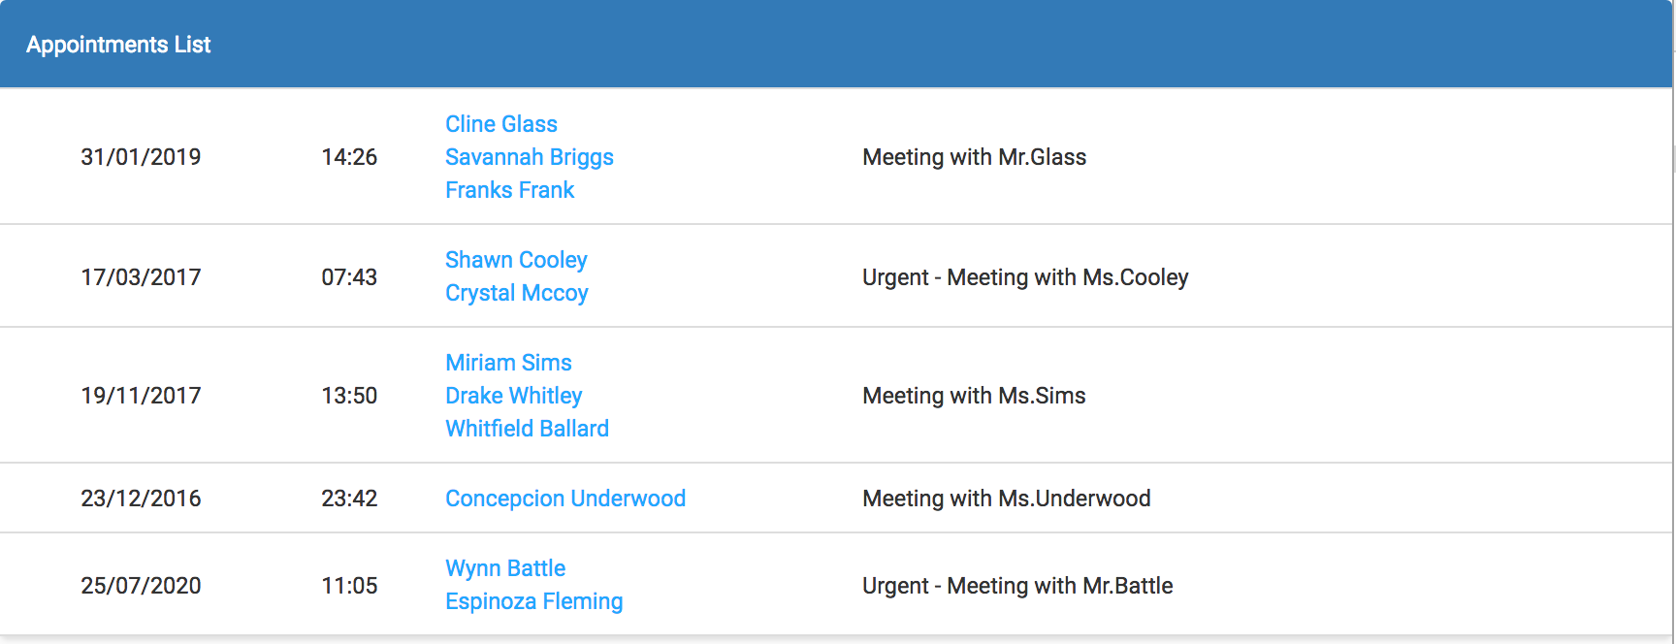

Instructions

Generating the Custom Widget
You will create an Appointments Widget using bb-cli. For this exercise, the Appointments widget will require both Extension and Model.
- Generate a widget using the generator.
- Navigate to statics/collection-training/src folder
- Run:
- bb-generate widget ng
- Answers to generate the widget:
- Name == > widget-training-appointments-ng
- Title - --- Accept default value ---
- Description - --- Accept default value ---
- Version - --- Accept default value ---
- Do you want to create an extension now? - --- Accept default value ---
- Do you want to create a model now, to - --- Accept default value ---
- connect the widget with APIs?
- Which version of Backbase are you using? - Backbase 5.X

Convert RAML into Data Modules
- Download the provided RAML files for the Appointments Widget from the "RAML" folder
- Put the RAML folder in the statics folder
- raml/appointments/appointments.raml
- Navigate to statics folder
- Use bb-convert to generate the Mock Data Modules:
- bb-convert raml raml/appointments/appointments.raml --template mock-ng --output collection-training/src -y

Inject Data Modules in Model
- Open statics/collection-training/src/model-training-appointments-ng/scripts/index.js folder
- Search for:
- import Model from './appointments';
- Below that line add the following:
- import dataProviderAppointmentsKey,
- { appointmentsDataKey } from 'data-bb-appointments-http-ng';
- Search for:
- .module(moduleKey, [
- ])
- Replace it by:
- .module(moduleKey, [
- dataProviderAppointmentsKey,
- ])
- Search for:
- '$q'
- Replace with:
- '$q',
- appointmentsDataKey,

Passing the data provider key as a parameter to the model.
- Open statics/collection-training/src/model-training-appointments-ng/scripts/appointments.js
- Search for:
- export default function appointmentsModel(Promise) {
- Replace it by:
- export default function appointmentsModel(Promise, AppointmentsData) {

Implement methods in the Model
- Replace the whole content inside the appointmentsModel function by:
- let getAppointments = () => {
- return AppointmentsData
- .getAppointments()
- .then(response => response.data);
- };

- return {
- getAppointments,
- };

Load appointments in Controller
- Open statics/collection-training/src/widget-training-appointments-ng/scripts/controller.js
- Remove the next snippet:
- model.load()
- .then(loaded => {
- $ctrl.items = hooks.itemsFromModel(loaded);
- })
- .catch(error => {
- $ctrl.error = errorMessage(error.code);
- bus.publish('widget-training-appointments-ng.load.failed', { error });
- })
- .then(() => { $ctrl.isLoading = false; });
- Search for:
- $ctrl.isLoading = true;
- Below that line add:
- $ctrl.appointments = [];

- model
- .getAppointments()
- .then(appointments => {
- $ctrl.appointments = appointments;
- })
- .catch(error => {
- $ctrl.error = errorMessage(error.code);
- bus.publish('widget-training-appointments-ng.load.failed',{ error });
- })
- .then(() => { $ctrl.isLoading = false; });

Create the view to display appointments
- Open statics/collection-training/src/ext-training-appointments-ng/templates/template.ng.html
- Replace the content of that file by:
- <section class="ext-training-appointments-ng container" ng-controller="AppointmentsController as $ctrl">
- <header ng-if="$ctrl.appointments.length === 0">
- No appointments available.
- </header>
- <div class="panel panel-primary" ng-if="$ctrl.appointments.length !== 0">
- <div class="panel-heading">Appointments List</div>
- <div class="panel-body no-padding">
- <ul class="list-group no-margin">
- <li class="list-group-item vertical-center" ng-repeat="item in $ctrl.appointments">
- <div class="col-sm-2 text-center">
- {{item.date | date:'dd/MM/yyyy'}}
- </div>
- <div class="col-sm-1 text-center">
- {{item.date | date:'HH:mm'}}
- </div>
- <div class="col-sm-3">
- <ul>
- <li ng-repeat="guest in item.guests">
- <a href="mailto:{{guest.personalData.email}}">{{guest.personalData.fullname}}</a>
- </li>
- </ul>
- </div>
- <div class="col-sm-6">
- {{item.subject}}
- </div>
- </li>
- </ul>
- </div>
- </div>
- </section>
- Create a Sass file in the "widgets" folder of the theme called "_appointments.scss"
- Add the following code in the Sass file:
- .ext-training-appointments-ng {
- .list-group-item {
- outline: none;
- }

- .vertical-center {
- display: flex;
- -webkit-align-items: center; /* Safari & Chrome */
- align-items: center; /* Firefox */
- }
- }
- Import "_appointments.scss" in the "_all.scss".
- Open "_shared.scss" and add the following classes:
- .no-padding {
- padding: 0;
- }

- .no-margin {
- margin: 0;
- }

Use the new widget on a page
- Import to CXP Manager using bb-package and bb-import
- Open your portal catalog
- At the bottom of the page you can see the Enterprise Catalog section:
- Input Appointments to filter the widgets:
- Click on the Appointments widget to add it to your portal.
- Open your portal
- Create a new page "appointments".
- Drop the widget on your "appointments" page.

Widget Extras

Module 02 - Exercise 01 : Develop an ICE Template
In this exercise you will create a new template for the Content Widget (ICE Widget)
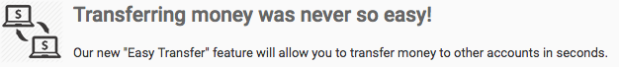

Instructions

Creating the feature
- Navigate to statics/collection-training/prebuilt
- Create a feature-training-media-article-template folder and navigate inside.
- Create a model.xml file inside with the following code:
- <catalog>
- <feature>
- <name>feature-training-media-article-template</name>
- <properties>
- <property label="Title" name="title" viewHint="admin,designModeOnly">
- <value type="string">Training Media Article Template</value>
- </property>
- <property label="Version" name="version" viewHint="designModeOnly">
- <value type="string">0.0.1</value>
- </property>
- </properties>
- </feature>
- </catalog>
- Create a templates folder and navigate inside
- Inside templates create a new media-article.html file with the following code:
- <div class="media be-ex-media-object">
- <div class="media-left">
- <img class="media-object" src="{{article.image.path}}" />
- </div>
- <div class="media-body">
- <h4 class="media-heading be-ex-title">{{article.bb:title}}</h4>
- <div class="media-body be-ex-content">{{{article.contentbody}}}</div>
- </div>
- </div>
- Import to CXP Manager using bb-package and bb-import

Change the template list on server level
- Open Enterprise Catalog
- Search Content in Enterprise Catalog
- Click on it to add it to your portal
- Click on the settings button
- Click on the PROPERTIES tab
- Add the following value to the end of Templates list:
- ,Media Object,$(contextRoot)/static/features/[BBHOST]/feature-training-media-article-template/templates/media-article.html
- Drop Content to one page and click on settings icon. The dropdown for Template property should display Media Object

Module 02 - Exercise 01: Structured Content
The objective of this exercise is to create reusable content by using Structured Content Type. We will also create a template and use it to render the Structured Content Item.
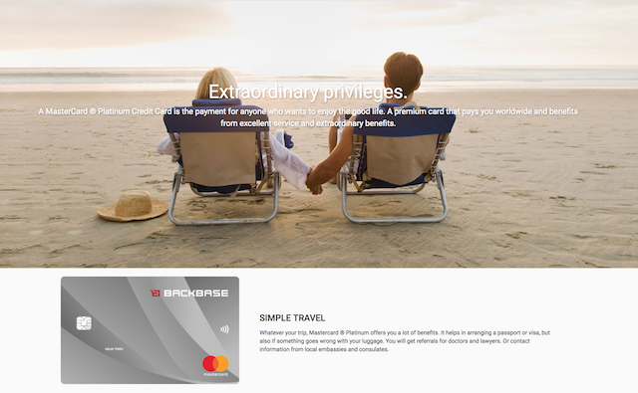

1. Create Structured Content Type
We are going to create a Structured Content Type - Credit Card
- Copy the folder structured-content-type-training-credit-card from assets folder provided in repository to statics/prebuilt in your solution.
- Open structured-content-type-training-credit-card/creditcard.json and note the changes.
- Package and Import.

2. Create an item from the created Type
- Open Portal Content and create an item for the new Structured Content Type.

3. Create the template to render Structured Content Type
We are now going to create a Template for that can render Credit Card Items.
- Copy the folder feature-training-structured-content-templates from assets folder provided in repository to statics/prebuilt in your solution.
- Open templates/CreditCard.html and review added data properties.
- Package and Import
Note: On CXP Manager, you may use images from images folder for banner and credit card.

4. Add styles to the template
- Copy the file _credit-card-detail.scss from assets/styles folder to custom theme folder.
- Import the file's dependencies such that it is included in theme.

5. Add Structured Content and refer to new template
- Open Portal Catalog and add Structured Content
- Click on settings icon and change the title e.g. Credit Card Structured Content
- Open properties tab and change the value of template to $(contextRoot)/static/features/[BBHOST]/feature-training-structured-content-templates/templates/CreditCard.html
- Go back to Page Management and put the Structured Content Widget on a page
- Drop the created item on the widget to render it

Container Development

Create a new Accordion Container
It's time to build our first custom container. In this exercise we're going to create a custom template for our container, and the container itself.

Create a Container Template
- Navigate to statics/collection-training/prebuilt
- Run
- bb-generate container templates
- Answers to generate the template for container
- Name == > template-container-training-accordion
- Title == > Training Accordion Container Template

Create a Container
- Navigate to statics/collection-training/prebuilt
- Run
- bb-generate container
- Answers to generate the template for container
- Name == > container-training-accordion
- Title == > Training Accordion Container
- Tags == > container
- Section Tag == > accordion
- Render Type - --- Accept default value ---
- Template name == > template-container-training-accordion
- Import to CXP Manager

Implement the Accordion UI

Objectives:
- Implement a three panels accordion.
- You must place a container's area inside of each panel. The first panel must be open by default
- Make sure there is a title for each area (configurable via a preference)
- When clicking the title, the specific area should become visible and the others should be hidden

Implementing the accordion plugin in your container

Import the accordion feature to your portal
An Accordion Plugin is provided for this exercise. Find the plugin in the vendor-training-accordion-js folder.
- Copy the folder vendor-training-accordion-js to statics/collection-training/prebuilt/
- Import the item into the portal.
- Add style to container-training-accordion.css file
- html.bd-designMode-true .container-training-accordion--area {
- min-height: 100px;
- }

- [data-role='accordion'] {
- font-family: helvetica, sans-serif;
- font-size: 0.7em;
- padding: 10px;
- }

- [data-role='accordion-section'] {
- margin-bottom: 10px;
- padding: 0;
- }

- [data-role='accordion'],
- [data-role='accordion-section'] {
- list-style: none;
- }

- [data-role='accordion-section-title'] {
- background: #f5f5f5;
- border: 1px solid #ddd;
- cursor: pointer;
- padding: 10px 15px;
- border-radius: 3px;
- }

- [data-role='accordion-section-title'].toggle-active {
- border-bottom-left-radius: 0;
- border-bottom-right-radius: 0;
- }

- [data-role='accordion-section-title'] [data-role='title-toggle'] {
- color: inherit;
- font-size: 1.2em;
- font-weight: 500;
- }

- [data-role='accordion-section-content'] {
- padding: 10px 15px;
- border: 1px solid #ddd;
- border-top: 1px solid transparent;
- border-bottom-left-radius: 3px;
- border-bottom-right-radius: 3px;
- margin-top: -1px;
- }

- [data-role='accordion-section-content'].content-closed {
- display: none;
- }

Use the accordion plugin in the container
In order to use the accordion we must add the reference to the container's config.xml file.
- Navigate to statics/collection-training/prebuilt/container-training-accordion
- Open config.xml file and add the following script tag inside the bb:resources node, without deleting any of the existing resources:
- <script type="text/javascript" src="$(contextRoot)/static/features/[BBHOST]/vendor-training-accordion-js/scripts/vendor-training-accordion-js.js"></script>
Tip: In the following article you'll find all the information for concepts covered in this topic.
How To Refer to Shared Resources Stored in a Feature

Add properties to manage accordion heading titles
In order to allow the user to change titles through the use of preferences, we are going to set them. We're going to use these properties in the template to replace static titles.
- Navigate to statics/collection-training/prebuilt/container-training-accordion
- Open model.xml file and add the following properties after the last existing property node:
- <property label="First Section Title" name="firstSectionTitle" viewHint="admin,designModeOnly">
- <value type="string">First Section. (This title comes from the model)</value>
- </property>
- <property label="Second Section Title" name="secondSectionTitle" viewHint="admin,designModeOnly">
- <value type="string">Second Section. (This title comes from the model)</value>
- </property>
- <property label="Third Section Title" name="thirdSectionTitle" viewHint="admin,designModeOnly">
- <value type="string">Third Section. (This title comes from the model)</value>
- </property>
Note: Don't forget to add the viewHint attribute if you want to allow the user to change properties values from the CXP Manager.
Read the following article for more information: How To Add Properties to a Widget

Adding the accordion markup to the container template
- Navigate to statics/collection-training/prebuilt/template-container-training-accordion/templates
- Open template-container-training-accordion.soy file
- Look for this div
- <div class="bp-container template-container-training-accordion" data-pid="{$item.name}">
- Replace its contents with the required backbase-js-accordion markup
- Replace static titles with the custom properties that contains section titles. (Ex. First Section Title):
- {$item.preferences.firstSectionTitle.value}
- Replace static content with an area placeholder. (Ex. First Section Content):
- <div class="bp-area template-container-training-accordion--area">
- {foreach $child in $item.children}
- {if parseInt($child.preferences.area.value) == 0}
- {include($child) |noAutoescape}
- {/if}
- {/foreach}
- </div>

Container event handlers
Every container can listen to events. This will allow the developer to execute some code when an event is triggered.
If you want to know the full list of supported events read the following article:
CXP Web Library - Events

Initializing your accordion with event handlers
- Navigate to statics/collection-training/prebuilt/container-training-accordion/scripts
- Edit the file container-training-accordion.js, so your container is initialized in the following event handlers:
- DOMReady
- preferencesSaved
- handlers: {
- DOMReady: function(){
- new Accordion();
- },
- preferencesSaved: function(event){
- if(event.target === this) {
- this.refreshHTML(function(item){
- //add code, HTML refreshed
- new Accordion();
- });
- }
- }
- }

Testing your brand new Accordion Container
- Open your portal
- Go to your portal catalog.
- Within the "Enterprise Catalog" section, search for training accordion
- Click on it to add it to your portal
- Go back to Page Management
- Create a new page and name it "Training Accordion"
- Drop your Training Accordion Container into that page
- Click the accordion's first title and drop a structured content widget on the area that will be displayed below.
- Repeat step #7 for the accordion's second and third titles
- Check it working in live mode
- Go back to design mode, click Training Accordion Container settings icon
- Look for Section Title fields and change its values
- Go to live mode again
- Check that the new titles are being displayed

